[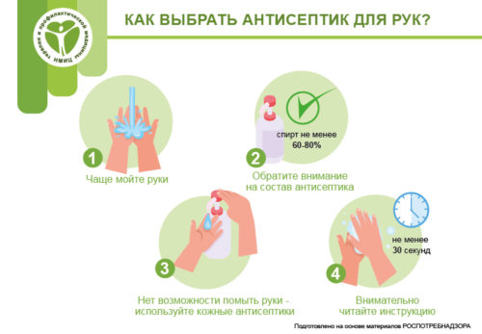](https://gnicpm.ru/wp-content/uploads/2020/05/bannery-dlya-sajta-7.jpg)